Structure & Function

- Structure is the way in which components relate to each other
- Function is the operation of individual components as part of the structure
- All computer functions are:
  - Data processing ❑ Data storage
  - Data movement
  - Control

Computer System: Hardware
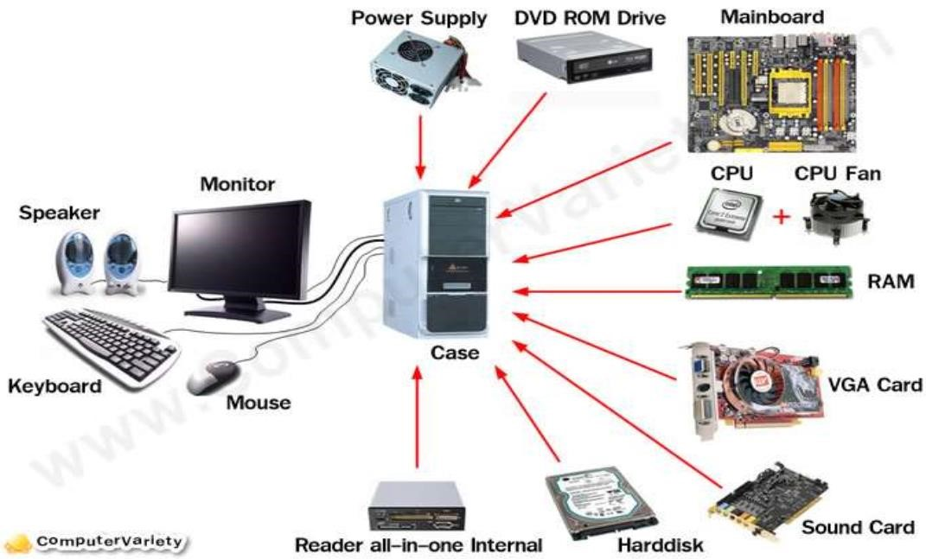

Computer System: Peripherals
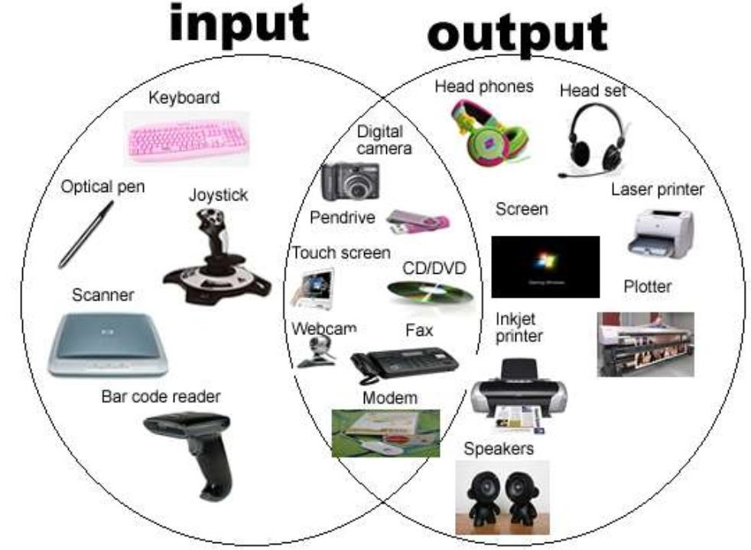

Computer System: Software
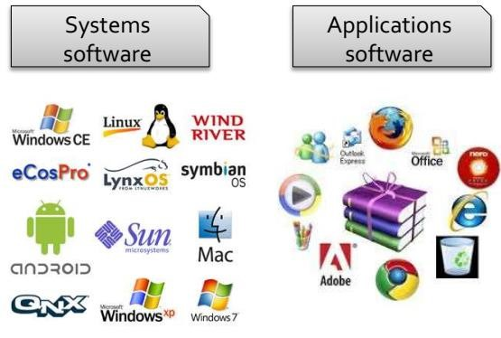

Foundation of CA
- Instruction set architecture
- Taxonomy / classification of computers and ISA
- Addressing modes
- RISC and CISC architectures
- Performance of different computer architectures
Structure - The CPU
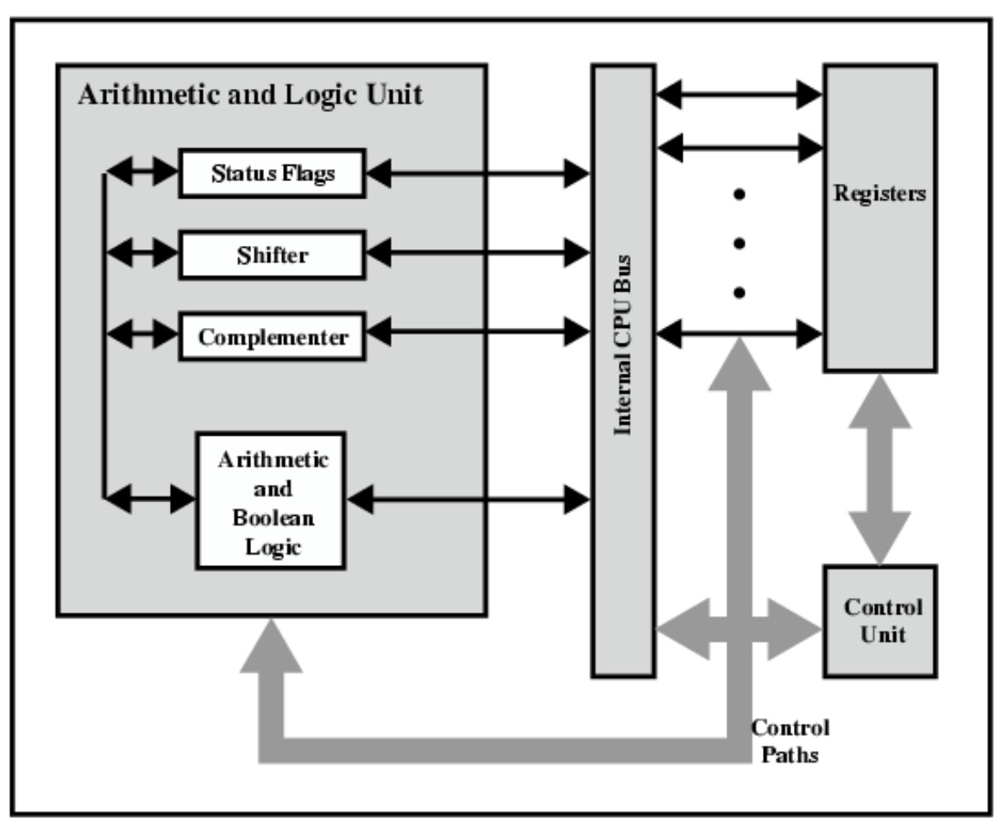
Computer
CPU
I/O
Memory
System
Bus

Processor Registers
- General registers
  - Store any transient data required by the program
- Control registers
  - Changes or controls the general behavior of a CPU
- Segment registers
  - Stores the starting address of the different segments defined in the program execution

General purpose registers:

- Data Registers
- Pointer registers
- Index registers
Data Registers
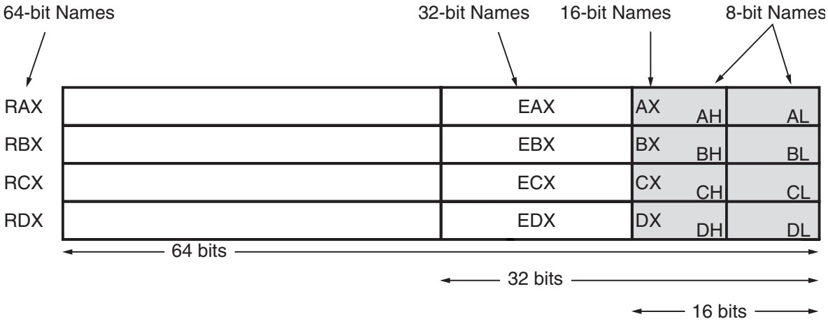◼ AX − Accumulator register
- BX − Base register
- CX − Counter register
- DX − Data register
- E := Extended, R := Register (mnemonic for 64-bit registers)
- L := register lower 8-bits, H := register higher 8-bits in 16-bit part

Pointer registers
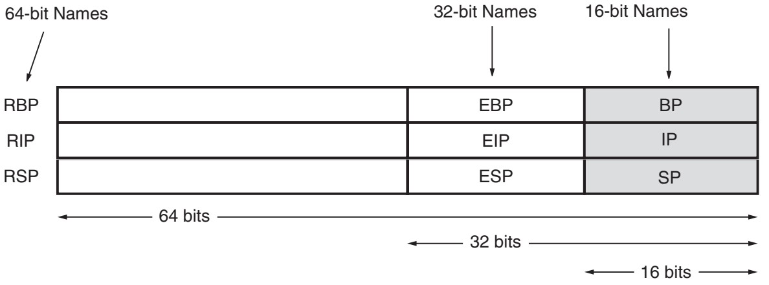
- BP − Base Pointer (16-bit register): referencing the parameter variables passed to a subroutine
- SP − Stack Pointer (16-bit register): provides the offset value within the program stack
- IP − Instruction Pointer (16-bit register): offset address of the next instruction to be executed

Index Registers
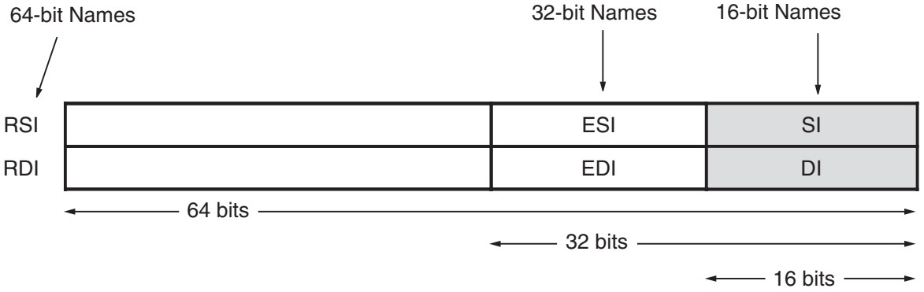
- SI − Source Index (16-bit register).
- DI − Destination Index (16-bit register).

NEW LECTURES

Control Register: Flag register

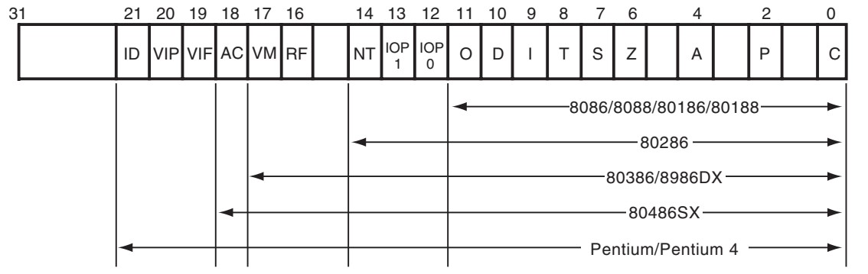
- Carry Flag (C) − It contains the carry of 0 or 1 from a highorder bit (leftmost) after an arithmetic operation.
- Parity Flag (P) − It indicates the total number of 1-bits in the result obtained from an arithmetic operation. An even number of 1-bits clears the parity flag to 0 and an odd number of 1-bits sets the parity flag to 1.

- Auxiliary Carry Flag (AC) − It contains the carry from bit 3 to bit 4 following an arithmetic operation; used for specialized arithmetic. The AF is set when a 1-byte arithmetic operation causes a carry from bit 3 into bit 4.
- Zero Flag (Z) − It is set if the last logical or mathematical instruction has produced a zero in its destination.
- Sign Flag (S) − It shows the sign of the result of an arithmetic operation. The sign is indicated by the high-order of leftmost bit. This flag is set to 1 if result is negative otherwise it is clear to 0. ◼ Trap Flag (T) − It allows setting the operation of the processor in single-step mode. The DEBUG program we used sets the trap flag to 1, so we could step through the execution one instruction at a time.
- Interrupt Flag (I) − It disables the external interrupt to processor when the value is 0 and enables CPU to be interrupted when set to 1.
- Direction Flag (D) − determines either the increment or decrement mode for the DI and/or SI registers during string instructions. If D=1, the registers are automatically decremented (bottom-up memory access); if D=0, the registers are automatically incremented (top-down memory access).
Overflow Flag (O) − It indicates the overflow of a high-order bit (leftmost bit) of data after a signed arithmetic operation.
- I/O Privilege Level field (IOPL): it defines privilege level of current process.
- Nested Task (NT): it controls execution of chained interrupts. It is set if current process is linked to the next process.
- RF (resume): it is used with debugging to control the resumption of execution after the next instruction.
- VM (virtual mode):VM flag bit selects virtual mode operation in a protected mode system.
- AC (Alignment Check): flag bit activates if a word or doubleword is addressed on a non-word or non-doubleword boundary.
- VI (Virtual Interrupt) Flag: it is a copy of the interrupt flag bit available to the Pentium-Pentium 4 microprocessors
- VIP (Virtual Interrupt Pending) Flag: it is used in multitasking environments in Pentium–Pentium 4 microprocessors to provide the operating system with virtual interrupt flags and interrupt pending information.
- ID (identification) Flag: it indicates that the Pentium– Pentium 4 microprocessors support the CPUID instruction. The CPUID instruction provides the system with its microprocessor information like its version number and manufacturer.
◼

CPU Registers
- Program Counter (PC)
  - An incrementing counter that holds the memory address of the instruction that is to be executed next
- Memory Address Register (MAR)
  - Holds the address of a block of memory for reading from or writing to
- Memory Buffer Register (MBR)
  - A two-way register that holds data fetched from memory (and ready for the CPU to process) or data waiting to be stored in memory. It is also called as memory data register.

CPU Registers
- Instruction Register (IR)
  - holds the instruction currently being executed or decoded.
- Instruction Buffer Register (IBR)
  - temporary register where the opcode of the currently fetched instruction is stored
- Accumulator (AC)
  - Performs Arithmetic and logical operations. It holds temporarily operands and results of ALU operations.
- Multiplier Quotient (MQ)
  - It holds temporarily operands and results of ALU operations.
  - For example, the result of multiplying two 40-bit numbers is an 80-bit number; the most significant 40 bits are stored in the AC and the least significant in the MQ.

Segment Registers
- Segment registers point to starting location in memory segment.
- CS (Code Segment) − A 16-bit CS register stores the starting address of the code segment part in memory.
- DS (Data Segment) − A 16-bit DS register stores the starting address of the data segment that contains data, constants and work areas.
- SS (Stack Segment) − SS register stores the starting address of the stack that contains data and return addresses of procedures or subroutines.
- ES( Extra Segment) − ES register points to extra data,
i.e., an additional data segment that is used by some of the string instructions to hold destination data.

Physical address generation

Default 32-bit segment and offset combinations
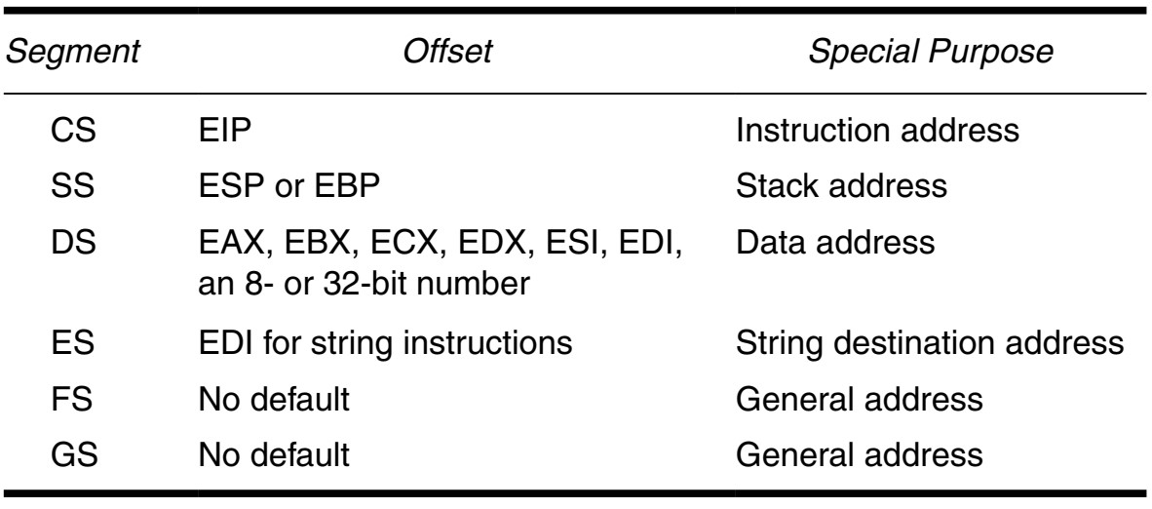
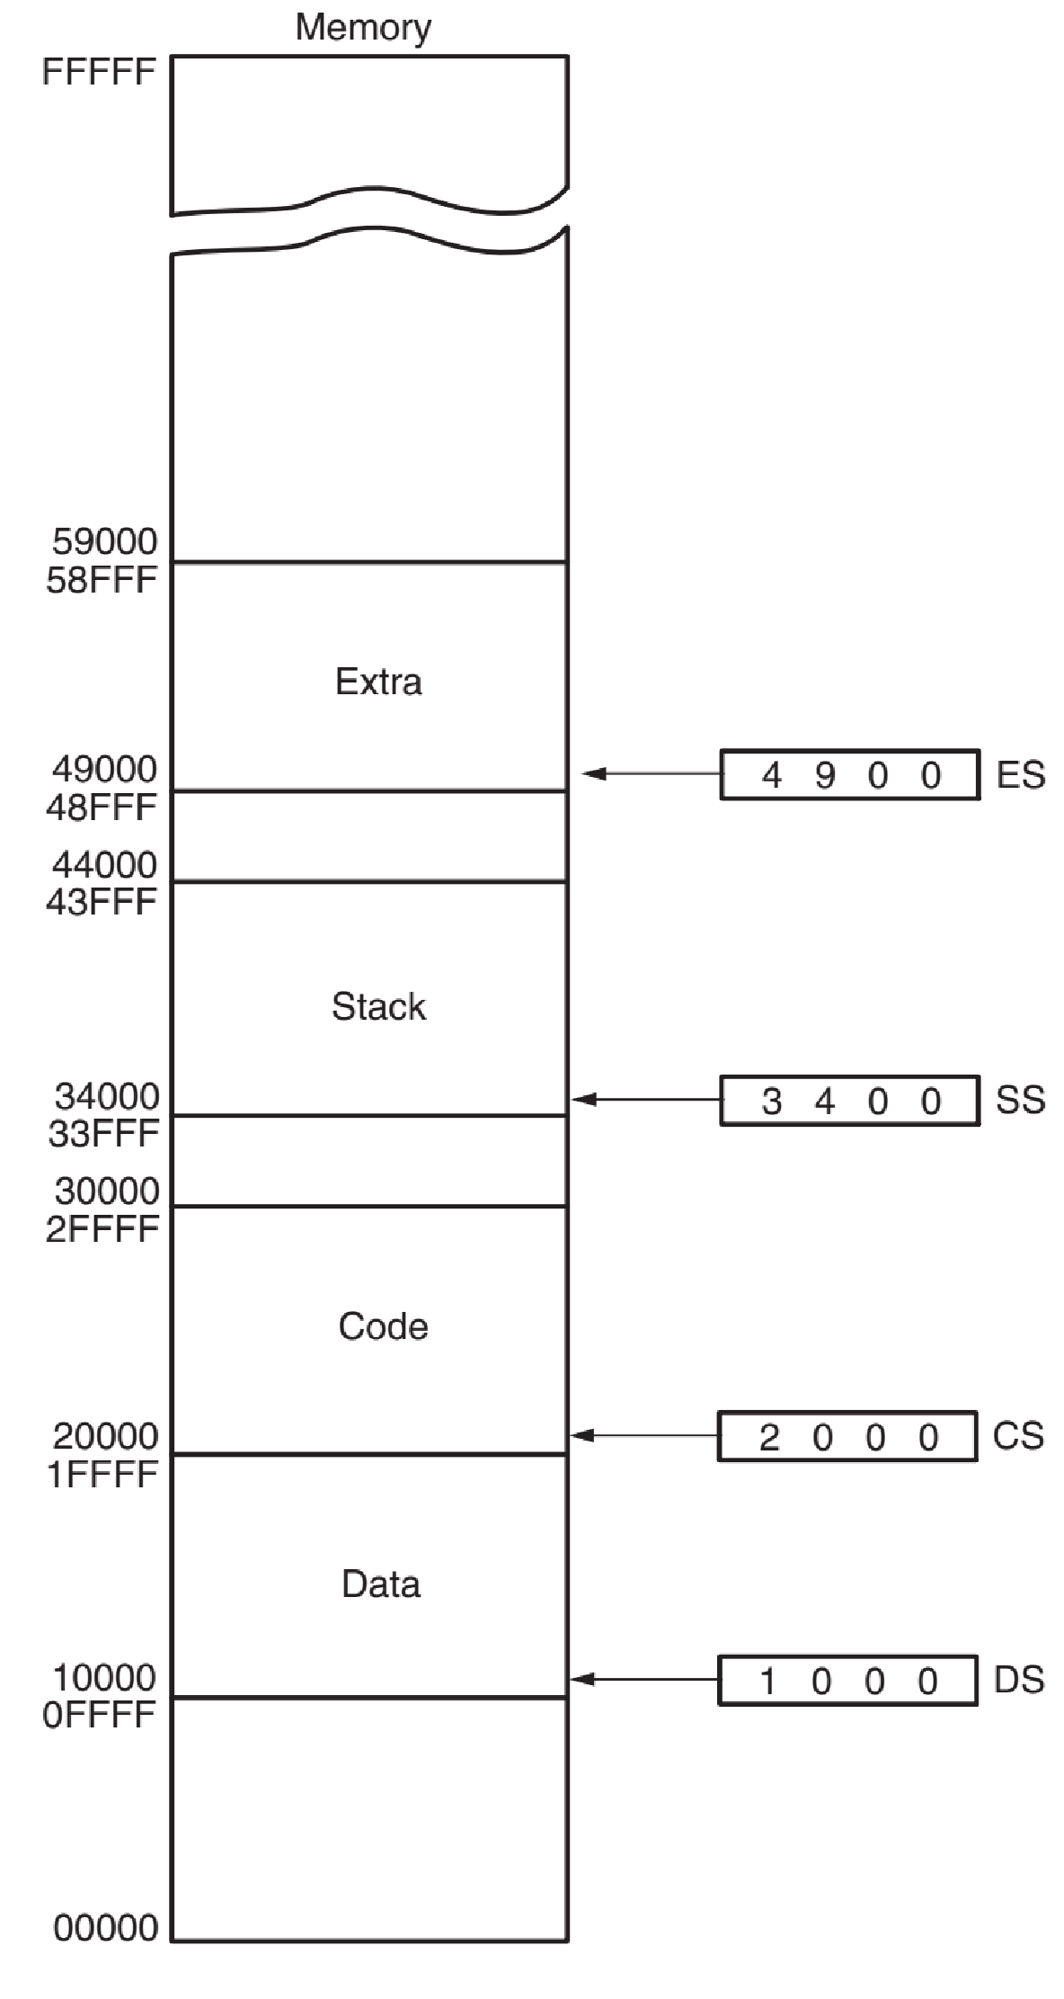
Physical Address
Calculation
◼
Offset is by default connected
to a segment register as:

Register size effect
- 8-bit register can hold 1 byte data and processor can access memory of size 256,
- 16-bit registers can hold a word (2 byte data) and processor can access 64k memory,
- 32-bit registers can hold double word (4-byte data) and
4GB memory can be accessed,
- 64-bit registers can hold quad word (8-byte data) and 18Billion GB memory can be accessed.

INSTRUCTION SET ARCHITECTURE: ABSTRACT OVERVIEW
ISA ?
- Instruction Set Architecture (ISA) refers to the actual programmer visible instruction set that serves as the boundary between the software and hardware.
- ISA consists of 1000 storage locations, called words, of 40 binary digits (bits) each.
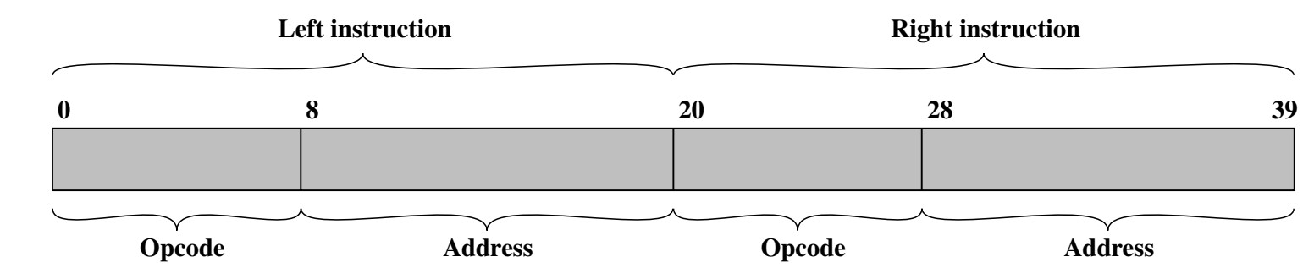
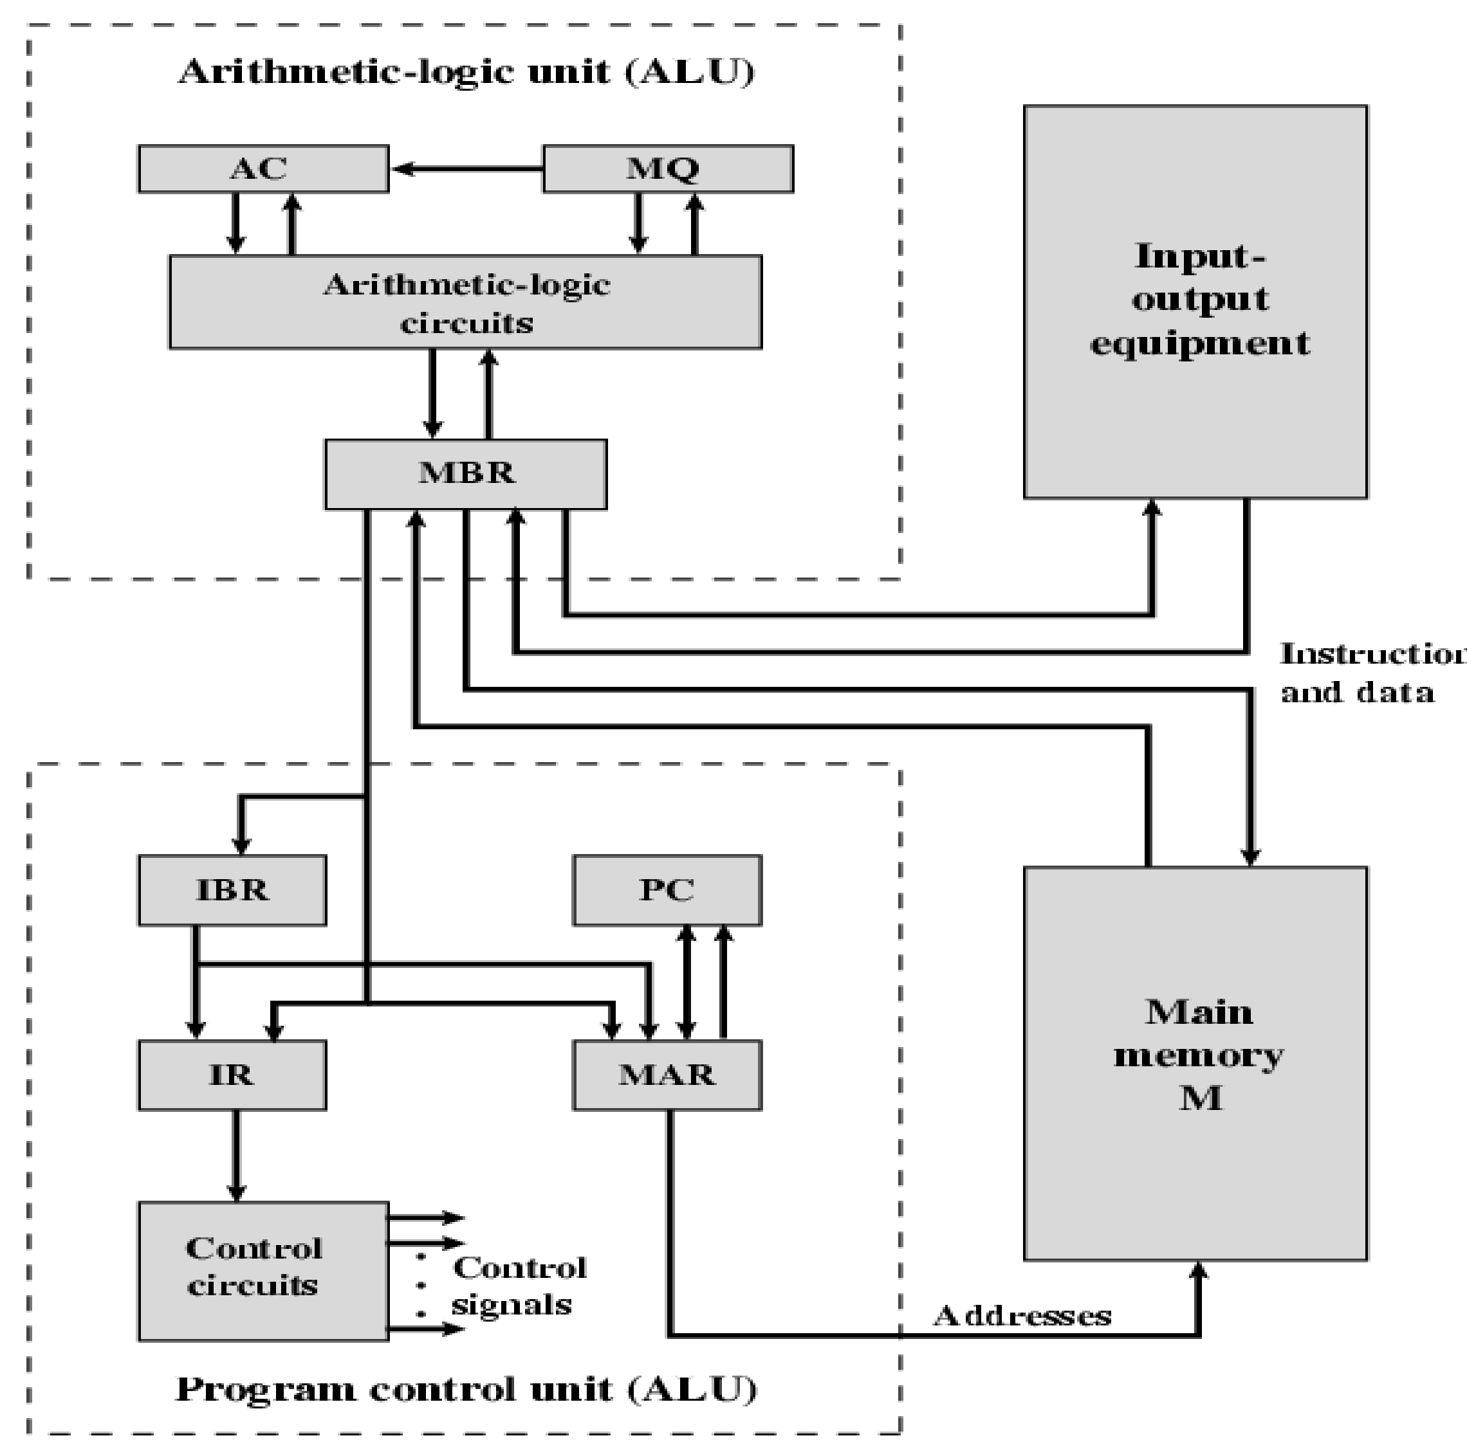
Structure
of
ISA
–
detail

Instruction Groups

- Data Movement Instruction
  - Move, Push, POP
- Arithmetic and Logical Instructions
  - Add, Subtract, AND, OR
- Program Control Instruction: controls program execution,
i.e., a set of instructions which control our instruction pointer (PC) register
  - If sequential execution of the program instructions or perform jump instructions etc.
- cmp ax, 0
- jne 1234
- Special Instructions: a set of instructions to change the processor state or behavior of CPU. ❑ cli sti ; clear / set interrupt flag

Instruction Set (IS)
◼ An instruction defines 4 features as:
- What operation to perform like ADD or MOVE is first part of an instruction. This part defines either data transfer, or arithmetic or a logic operation,
- Second part tells information about operand, i.e., instruction will tell from where to fetch the operand like from register or from a memory location,
- Third part specifies the destination address of the CPU operation. For example, after adding two numbers where should the result store.
- Last part defines what next instruction needs to be executed, by default this is address of next instruction in the queue. However, in case of jump operation, this will specify the address of the next instruction specified by the jump operation.

Classes of IS based on addresses

- Note that 0~4 addresses need to be specified in the instructions
- Instructions are classed into 5 classes as:
  - 4-address instructions ❑ 3-address instructions ❑ 2-address instructions
  - 1-address instructions
  - 0-address instructions (Stacked based machine)

4-
8 24
1
-
Byte
3
Bytes
3
Bytes
3
Bytes
3
Bytes
Operation
Code
Destination
address
Operand 1
address
Operand 2
address
Next
instruction
address
2
= 256 instructions possible
2
= 16 MB Memory accessible
- Instruction size = 1+3+3+3+3 = 13 bytes
- Note that if data bus is of 1-byte, maximum of 1 byte data is fetched from memory to CPU in one clock cycle.
- Number of bytes accessed from memory:
❑ 13 for instruction fetch + 6 bytes for operands + 3 bytes for storing result in destination = 22 bytes

3-
1-Byte | 3 Bytes | 3 Bytes | 3 Bytes
Operation  Code | Destination address | Operand 1 address | Operand 2 address
- Instruction size = 1+3+3+3 = 10 bytes
- Number of bytes accessed from memory:
❑ 10 for instruction fetch + 6 bytes for operands + 3 bytes for storing result in destination = 19 bytes

2-
1-Byte | 3 Bytes | 3 Bytes
Operation  Code | Operand 1 + Destination address | Operand 2 address
- Instruction size = 1+3+3 = 7 bytes
- Number of bytes accessed from memory:
❑ 7 bytes for instruction fetch + 6 bytes for operands + 3 bytes for storing result in destination = 16 bytes

1-
1-Byte | 3 Bytes
Operation  Code | Operand 2 address
- Accumulator based machine has one operand stored in the accumulator register in CPU while second operand is fetched from location specified in source part.
- Instruction size = 1+3 = 4 bytes
- Total memory access bytes = 7 {4 + 3 (Operand 2 fetch) + 0 for storing result as the result is stored back in the accumulator register}

0-
1-Byte
Operation Code
- Stacked based machine takes all the operands from the top of the stack and the result is also stored back on top of the stack, therefore, there is no need for source addresses.
- Total memory bytes access: 10 {1+ 6 (operands access from stack) + 3 (storing destination)}

Summary
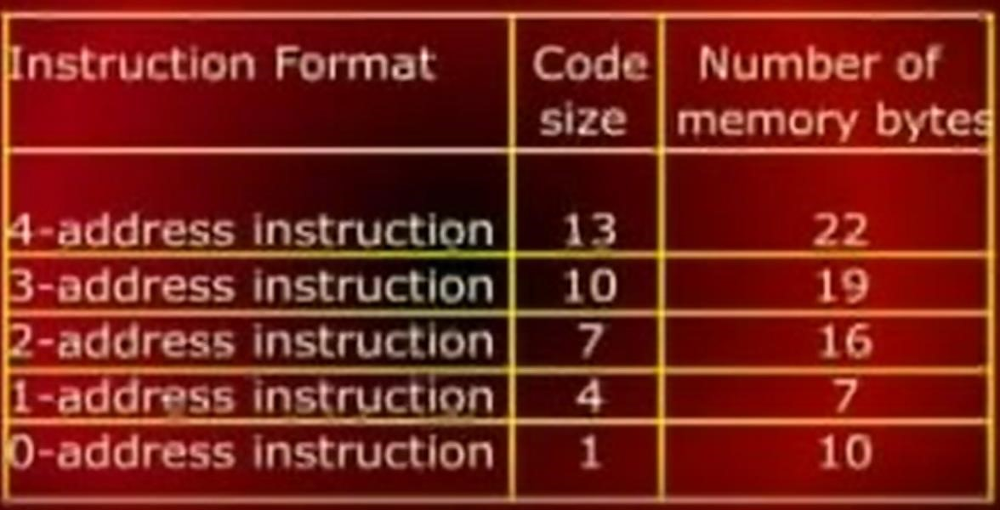
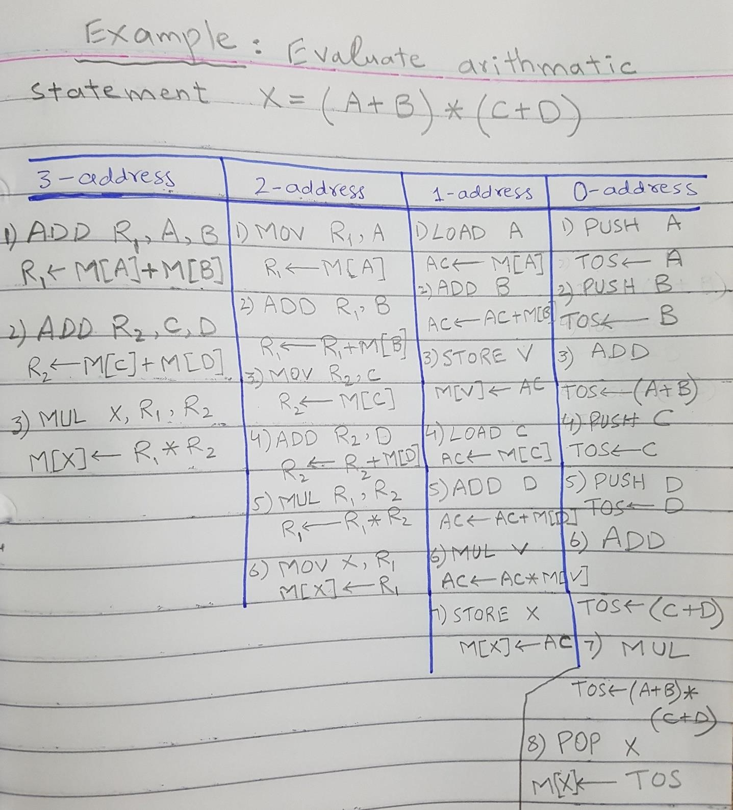
Example

